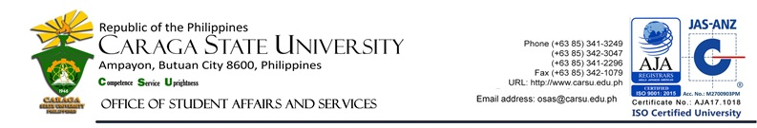
Student Organization Accreditation Application Form

INSTRUCTION: Please fill 2 copies out this form NEATLY and CLEARLY and submit these together with the other requirements.

Name of Organization: ___________________________________________________________________________________________________________

Nature of the Organization:  Academic  Religious/Faith-based  Fraternity and/or Sorority  Service-oriented

Application Date: _____________ S.Y.: __________ Semester: ____ No of Members: _______ No. of Officers: ______________

Type of Membership:  New  Renewal*

*Organizations seeking for renewal of recognition must clear all liabilities and requirements from previous academic year.

List of Requirements:
For New Applicants:  - Letter of Intent addressed to the Director of the Student Affairs and Services, LCO President and to its Council President  - Organization’s Constitution and By Laws  - Written Document of the Initiation Rights (for Fraternities and Sororities only)  - Confirmation of approval from the Adviser(s)  - List of Officers  - List of Members  - Annual Action Plan  - Personal Profile of Every Member  - Membership Fee (Php 500.00) |  | For Renewal:  - Letter of Intent addressed to the Director of the Student Affairs and Services, LCO President and to its Council President  - Confirmation of Approval from the Adviser(s)(provided that the organization has appointed/elected new adviser(s) for the present school year)  - List of Officers  - List of Members  - Annual Action Plan  - Accomplishment Report  - Personal Profile of new Members  - Membership Fee (Php 500.00)

DISCLAIMER
 By the authority vested on me as the President/Representative of our organization, I declare that these information has been accomplished by me and that it is true and correct; that we as an organization understands the provisions stipulated in the policies and guidelines which governs the campus organizations; and, that I am giving permission for the authorized personnel to verify the records of each of our members in the Caraga State University Information System.
____________________________
Signature

To be filled out by Authorized personnel ONLY.

RECOMMENDATION:

Council President :  Approve  Disapprove ________________________________
Signature over printed name

Descriptive Evaluation/Recommendation (if applicable)
________________________________________________________________________________________________________________ _______________________________________________________________________________________________________________

LCO President :  Approve  Disapprove ________________________________
Signature over printed name
Descriptive Evaluation/Recommendation (if applicable)
________________________________________________________________________________________________________________ _______________________________________________________________________________________________________________

ACTION:  Approve  Disapprove

Descriptive Evaluation/Recommendation (if applicable)
________________________________________________________________________________________________________________
________________________________________________________________________________________________________________
________________________________________________________________________________________________________________ _______________________________________________________________________________________________________________

ADAM ROY V. GALOLO, PhD
Director, OSAS
Date: ______________
F-OSAS-ASO-012
Rev. 1 04/11/2019

